# Question 01

## Code

number = 1

while number<=5

disp('Hello')

end

## Solution

Infinite

# Question 02

False.

# Question 03

In while loop if initialization is done during condition checking, then initialization is done each time the loop iterate. In 'for' loop iteration statement is written at top, hence, executes only after all statements in loop are executed. In 'while' loop, the iteration statement can be written anywhere in the loop.

# Question 04

The main difference between break and continue is that break is used for immediate termination of loop. On the other hand, 'continue' terminate the current iteration and resumes the control to the next iteration of the loop.

# Question 05

## Code

clc

clear all

% Q05

x=[0:100];

j=1;

for i=1:length(x)-nnz(rem(x,3))

if(rem(x(j),2)==0)

disp([num2str(x(j)),' is even'])

else

disp([num2str(x(j)),' is odd'])

end

j=j+3;

end

## Output

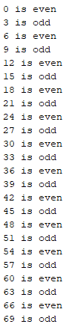

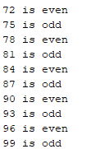

# Extra Credit Question

## Code

clc

clear all

x=0;

vec=[];

while x<=200

if(rem(x,4)==0)

vec=[vec x];

end

x=x+1;

end

disp('Multiples of 4 are:')

vec

## Output

